  - ENEMLOS NEWSLETTER Issue 3/2023
July/August/September/October 2023
II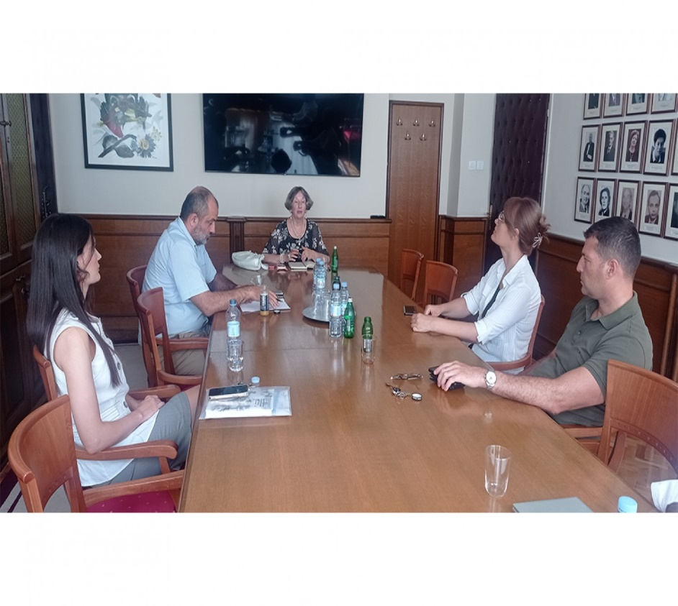 |  |  | 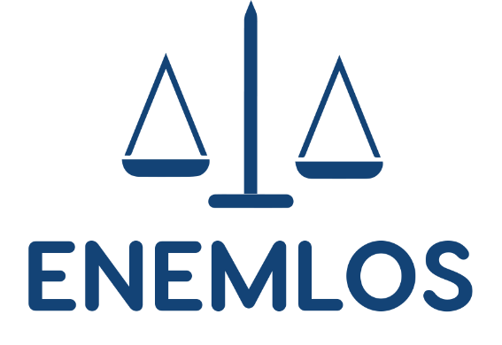  LEGAL CLINICS IN SERVICE OF VULNERABLE GROUPS: ENHANCING THE EMPLOYABILITY OF LAW STUDENTS THROUGH PRACTICAL EDUCATION
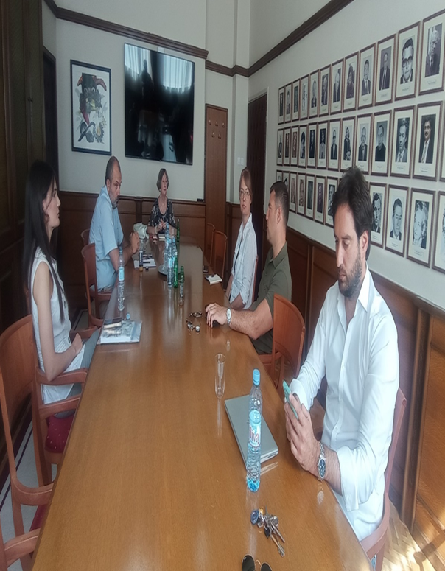 |  |  | The project management team meeting  13th September 2023
–––––––

Faculty of Law Zagreb: Training on Legal Clinics & Promotion of the Guidebook on Best Practices in Running Live Client Clinics
on 26th September 2023
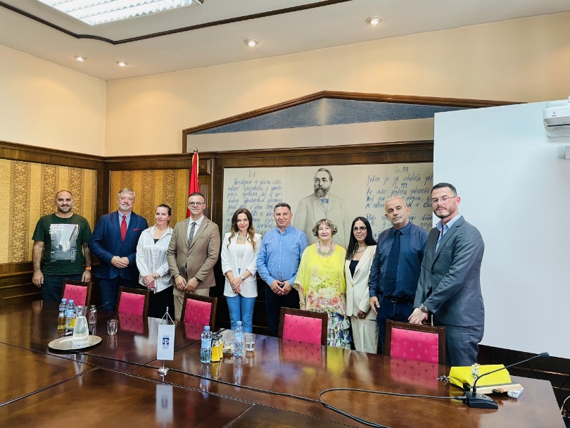 Podgorica, the Faculty of Law, 12 October
2023:
Management Board Meeting
